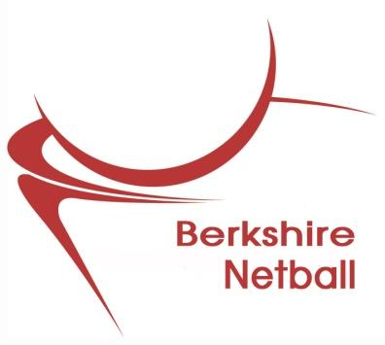

**Berkshire Netball**

**Annual General Meeting**

**A G E N D A**

**Thursday 31 August 2023**

**St. Annes Manor – Wokingham - 7.30pm**

1. **Apologies for Absence**

**2. Minutes of last AGM – September 2022**

1. **Matters Arising**
2. **Adopt Officers' Reports:-** Chairperson

Competitions

Coaching

Umpiring

Development

Treasurer

Publicity

Events

Berkshire NDO

1. **Adopt League Reports:-** Ascot (Charters Triple SSS)

**(Will be displayed on** Bracknell

**Berkshire Netball** Maidenhead

**Website after AGM)** Newbury

Berkshire Premier

Reading

1. **Adopt accounts and reports**
2. **Election of Officers**