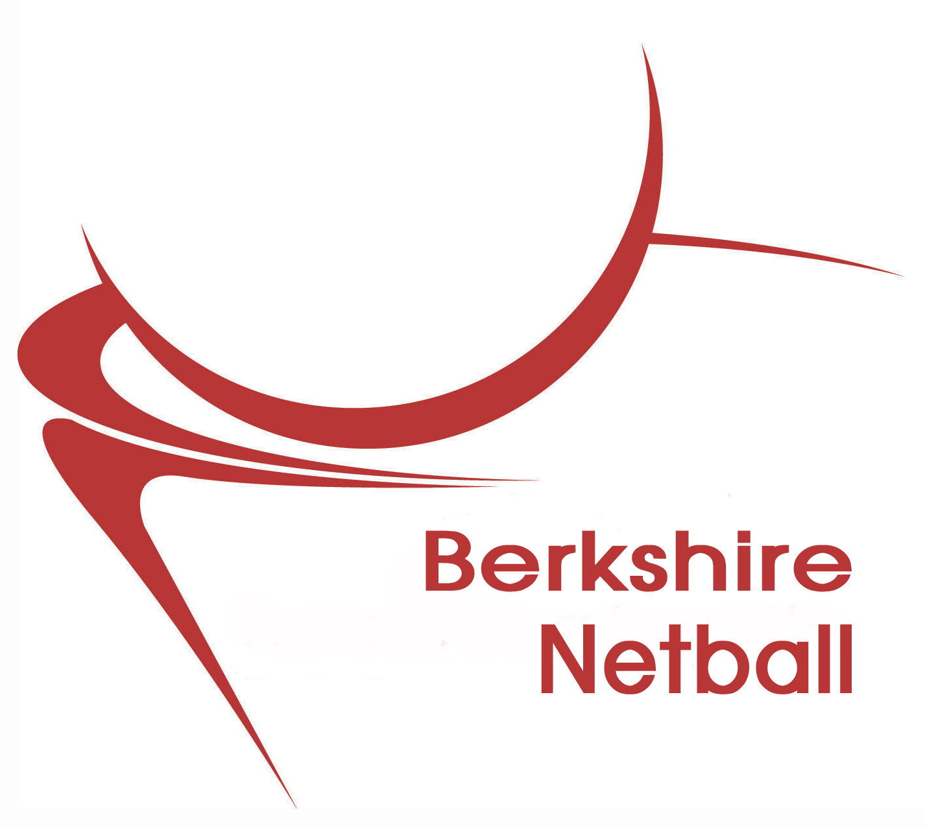
BN Coaches, Umpires, Tutors, Assessors Funding Application Form

League/Applicant Contact Details:
Applicant Name: ____________________________________________________________
Address:___________________________________________________________________
______________________________________________________________________________________________________________________________________________________________________Postcode: _____________________________________________________
Home Telephone: _____________________ Mobile: ________________________________
Email: _____________________________________________________________________

Course Details:
Course Title:

Date of Course:

Course Venue:

Course Provider:

Course Cost:
£

Other Information:
Have you approached any other organisation for support of Funding for this course e.g Netall Club, League, SRMB or Local Authority. If yes please state:

What are your reasons for wanting to go on the above course?

By going on the above course, how will this support your development within this area of netball?

How can you support Netball in Berkshire by completing this course?

Course Tutor:

Please ask your tutor to complete this section on completion of the above course:

Name: ____________________________________ Contact No: ____________________________________
Signed: ___________________________________

Date: _____________________________________

BN Administration Only:
Course: UKCC Coaching Umpiring Other

Agreed Contribution from BN Funds: £ _________________________

Signed: _________________________

BN Position: ___________________________

Please note Funding Applications will only be accepted up to 4 months after the completion date of the named course.
If successful in your application you will be asked to help at various events, tournaments, trials, coaching or umpiring sessions with in Berkshire.

I agree to the above if successful in gaining funding from Berkshire Netball

Signed

Please complete this form and return to:

Berkshire Netball Secretary
Julie Arnold
8 Otterbourne Crescent
TADLEY
RG26 3UJ

Email: berkshirenetballsecretary@gmail.com

